Car Parking System Application
Student: Boza Eduard, ETTI
Scenario:
You open the Car Parking System application on your smart phone. The entirety of lots (available and unavailable) is displayed, as well as the remaining waiting time until the unavailable parking lots become unoccupied. Then, you select a parking lot number, where you can park your car. The interval of choosable slot times is 30 minutes. Select for how long you will have your car parked in the selected lot. Let's say you select 2.5 hours. You pay via your credit card. You can leave the parking area within 2.5 hours. Even if your stay was just 1.5 hours, you pay for 2.5 hours. If you want to extend your stay, you will have to do it 30 minutes prior of your designated leave time. If nobody reserved your parking lot past the 30 minutes landmark, you are still able to extend your stay.

- Draw the architecture of the system you thought about (schematic on a sheet)
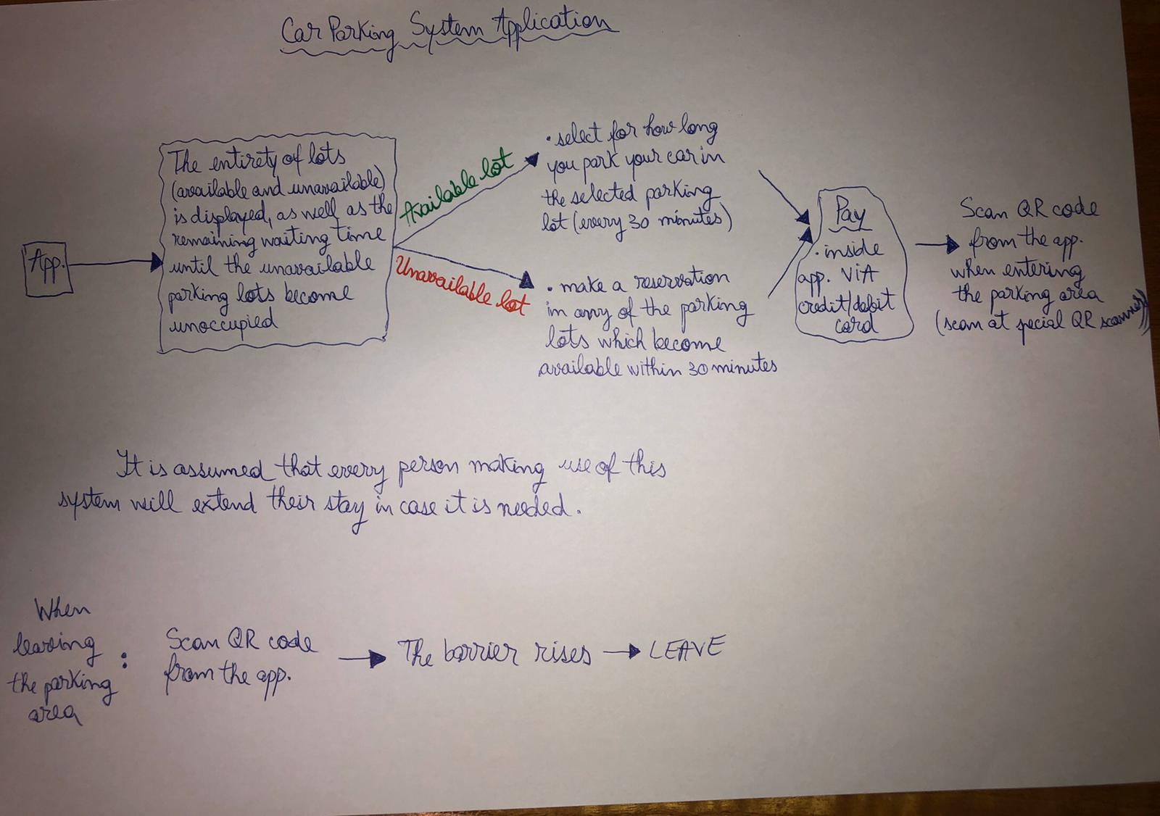

2) Tell us how do you imagine the graphical interface of the application and which fields should be mandatory (for example login interface, payment method etc.)?
I believe that the graphical interface of the application should be user friendly, prioritizing ease of use. The user must reach the desired feature in the least possible steps.
Mandatory:
-login
-payment VIA credit/debit card
-a feature that displays all(available and reserved) lots in the parking area
-contact number for any problems(user friendly)
Optional:
-feedback
-change background colour(personalization)
-for frequent customers, a system of subscriptions will be implemented:
e.g.: for 1 month: 2.5% discount
for 3 months: 10% discount
for 6 months: 25% discount

3) Explain to us what are your chosen technologies and why?
Technologies that I have chosen for this project are: QR Scanning and Online payment.

QR Scanning because:
-fastest identified way of „ticketing”

Online payment:
-remote access
-during peak hours, you avoid queuing

4) You are the parking administrator and your clients are complaining that they are receiving errors when they want to make a payment. What steps will you take to discover the errors?
1. Point out to the customer that they should check if there is enough balance on their account(s)
2. If there is enough balance, the client should be instructed to check if the money was frozen or if the transfer actually went through
3. If the money was not frozen, then it indicates that there was an issue with the system and report this to the immediate superior
As a thumb rule, when such an unplesant situation occurs, myself, as a parking administrator, will take responsability for this on behalf of the company, will apologize to the customer, and I will also enforce the company’s policy of making the service free due to the circumstances.

